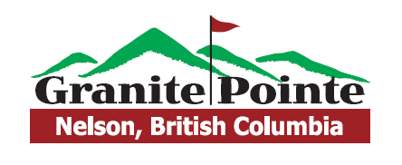

Nelson City Open Results
Men’s Division
1st Place – Jeff Langin (63) $100 Gift Card
1st Net – Grant Davidson NET (68) $80 Gift Card
KP #17 – Yianni $20 Gift Card
Long Drive – Khai Barth $20 Gift Card
Senior’s Division
1st Place – Rex Skarbo (73) $100 Gift Card
1st Net – Bob Hall NET (69) $80 Gift Card
KP #7 – Len Fuss $20 Gift Card
KP #17- Rex Skarbo $20 Gift Card
Long Drive – Lance Gotzy $20 Gift Card
Ladies Division
1st Place – Cathy Fuss (98) $100 Gift Card
1st Net – Dara Davidson NET (65) $80 Gift Card
Long Drive – Amber Bruner $20 Gift Card
KP #7 – Cathy Fuss $20 Gift Card
KP #15 – Helen Houle $20 Gift Card
Long Putt – Amber Bruner $20 Gift Card
Long Putt – Dennis Houle $20 Gift Card

